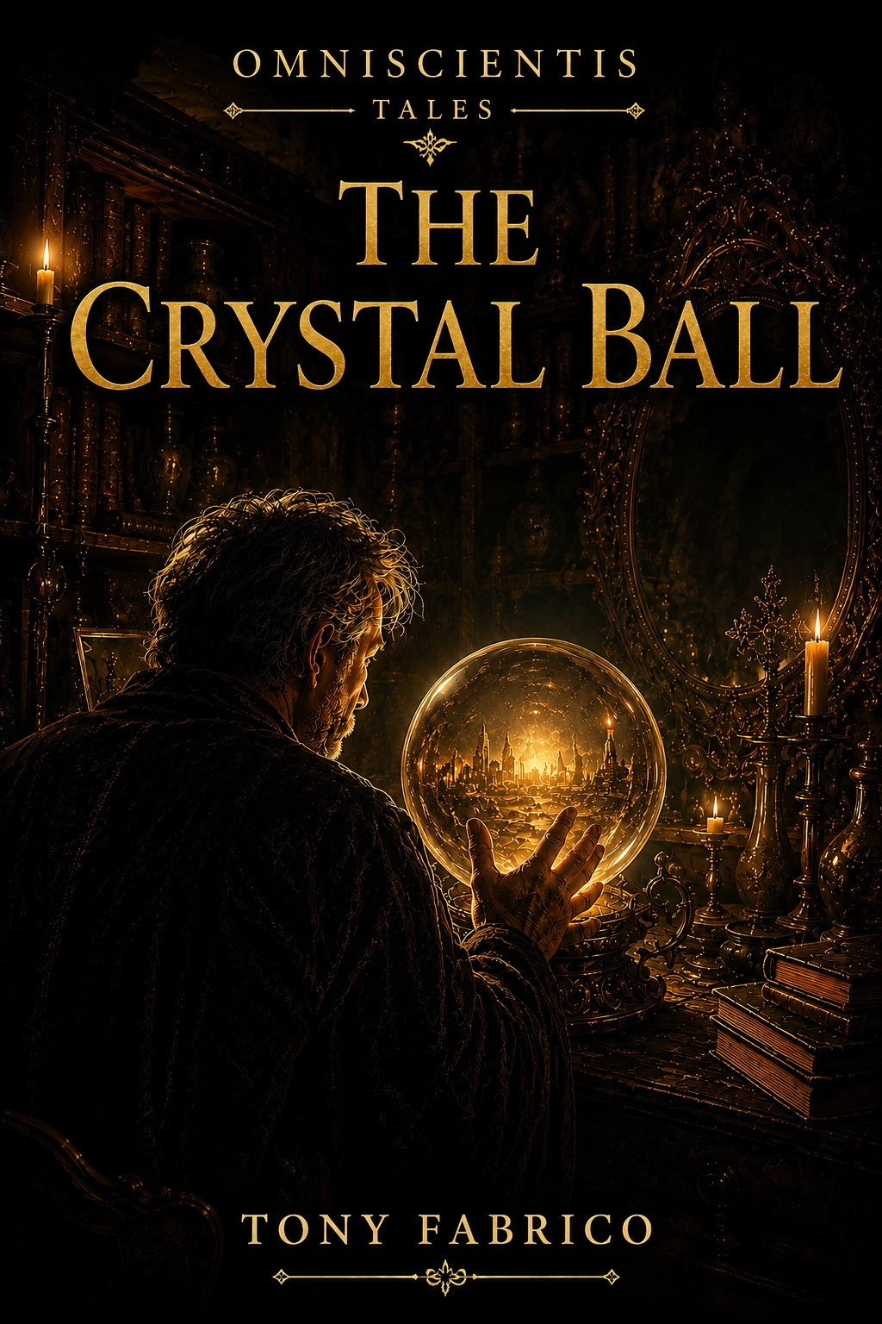

OMNISCIENTIS · Tales
The Crystal Ball
© Tony Fabrico
First Edition · 2026
All rights reserved.
✦
This story is part of the Omniscientis narrative universe.
✦
No part of this publication may be reproduced,
distributed, or transmitted in any form or by any means,
without prior written permission from the author,
except as permitted by applicable law.



Prologue
Time.

It buries cities. Erases roads.
Turns certainty into legend.
And even now, as we speak,
it is slowly being consumed—like the oil in a lamp.

Some believe that
time is a path already laid before us.

That the past, the present, and the future all exist at once,
and that every event occupies a place
that cannot be changed.

Others
claim that only the present is real.

That the past survives only in memory,
and that the future is nothing more than
a collection of possibilities.

Time
has fascinated mankind since the beginning of days.

The sages of old sought answers in the stars,
in dreams,
in numbers.

Some legends say
they even built strange instruments
for the sole purpose of unveiling what was yet to come
—destiny itself.

Those secrets have been lost to the passing centuries.

But…
What would you do
if you could know the future?

What I am about to tell
happened so long ago that no one remembers when.
In a place that no longer appears on any map.
In a small village called Drywind,
north of the Flatlands, not far from Prosperous City.

There once stood an auction house there.

And this story begins exactly there.

Act I - Warning
“Knowledge
changes the observer,

and the observer
changes that which is observed.”

— Fabhrius

Chapter 1: Master Dahg’s Auction House
Part 1 – The Shop
In a small village called Drywind, there once stood an auction house known as Master Dahg’s Auction House. The shop stood at the far end of the market road, just where the last houses of the village gave way to the open fields.
It was an old building of weathered wood, darkened by the passing years, with a long covered porch that creaked beneath the weight of every visitor. Outside were displayed used tools, worn chests, and all manner of ordinary objects rescued from oblivion.
Inside lay a vast hall where sunlight barely managed to penetrate the narrow, dust-covered windows, leaving most of the room shrouded in shadow.
The wavering flames of candles and oil lamps gave the place an air of mystery, casting restless shadows across the walls and making the objects seem to move whenever they were not watched directly.
The air smelled of aged parchment, damp wood, and melted wax. Antiquities from distant lands and forgotten ages crowded every corner. Stuffed animals watched from the shelves with dull glass eyes. Strange copper instruments rested upon cluttered tables. Old weapons coated in rust hung from the beams overhead. Mirrors framed in ornate carvings returned dim reflections. Furniture engraved with incomprehensible symbols waited silently in the darkest corners.
Every object seemed to hold a story. Memories. Misfortunes. Secrets. All preserved within the memory of a silent witness.
Perhaps they were merely superstitions. Or perhaps they were not.
What is certain is that most of the people of Drywind avoided spending too much time inside that shop.
Many truly believed that the objects gathered within the auction house were… something more than mere old things.

✦ ✦ ✦

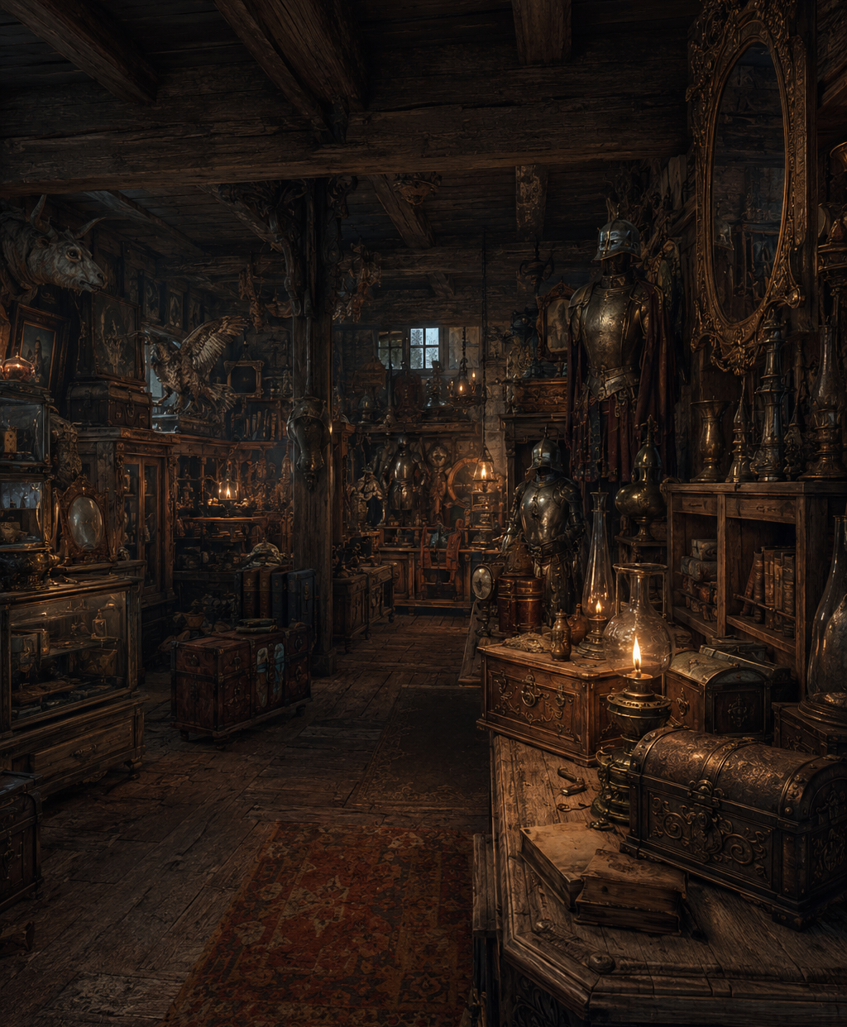
✧ Master Dahg’s Auction House ✧

Part 2 – Dahg the Shopkeeper
The owner of the shop was a fifty-year-old man named Dahg. He lived alone in the rooms above the store.
He had no wife, no children, and no other family. Few visitors ever called on him except for matters related to the business.
He was a reserved man of few words and simple habits. He attended the village celebrations only when necessary and seldom lingered in long conversations outside the taverns or around the wells. He preferred the quiet company of his ledgers, the order of his shelves, and the silent presence of the objects that filled his shop.
Yet those who knew him well understood that beneath his distant manner was an honest man.
Dahg remained patient when others lost their temper. He listened before passing judgment. He kept his word even when doing so worked against his own interests.
He paid his debts on time and honored every agreement he made, whether great or small. If a widow came to sell an old tool, Dahg offered her a fair price. If a traveler forgot a purse of coins upon the counter, he would find it untouched when he returned to claim it. And when disputes arose between neighbors over the value of some object, it was not uncommon for them to seek the shopkeeper’s opinion, trusting that his judgment would be impartial.
For that reason, he was respected.
But not necessarily understood. For the auction house exerted a strange influence upon the imagination of the villagers.
Many people in Drywind had crossed the shop’s threshold only once or twice in their entire lives. Some avoided it altogether. The place filled them with a discomfort that was difficult to explain. And over time, part of that feeling came to cling to its owner as well. Not because Dahg had ever done anything wrong. Nor because there were any rumors about him. It was simply that people tended to distrust what they did not understand.
And for many villagers, it was difficult to separate the man from the collection of strange objects, forgotten relics, and mysterious antiques that filled the auction house.
So when they saw Dahg walking through the streets of the village, they greeted him with respect. But more often than not, they waited until he had turned the corner before continuing their conversations.
✦ ✦ ✦

Part 3 – Business
Life in Drywind moved at a slow pace.
The days resembled one another, and the seasons arrived with dependable regularity. Neighbors had known each other for years. Children grew up in the same dirt roads where their parents had once played. Travelers were so rare that the arrival of a stranger could become the subject of conversation for days.
For Dahg, that tranquility had its advantages. But it also had its drawbacks.
Master Dahg’s Auction House was an unusual establishment, and its finest items rarely found buyers among the villagers.
Most customers came looking for used tools, simple furniture, or household goods. Yet the most valuable pieces in his collection—ancient relics, ornate furnishings, strange instruments, and objects from distant lands—were beyond the means of nearly everyone in Drywind.
His true customers lived in Prosperous City. Nobles, wealthy merchants, scholars, and collectors who appreciated rare curiosities and were willing to pay handsomely for them.
As a result, Dahg had become increasingly dependent on trade with the city. Fortunately, over the past few years he had managed to save a considerable amount of money. And only a few months earlier, he had made the most important investment of his life.
A new wagon.
It was a magnificent freight wagon, built by the finest craftsmen in the region. Sturdy, spacious, and far more reliable than the old wagon he had used for years. To anyone else, it might have seemed like nothing more than a tool of the trade. To Dahg, it was something far more important. It represented the future.
With it, he would be able to transport more valuable goods, travel to more distant towns, and establish new trade routes. It was the centerpiece of a plan he had spent years carefully preparing. But it was not the only change on the horizon.
Long ago, he had inherited a parcel of land south of Drywind. Land he had never used and was now preparing to sell. The transaction was already being handled by a scribe in Prosperous City.
Everything seemed to be proceeding exactly as planned. The documents were ready. The agreements were nearly finalized. Dahg had even purchased passage on a riverboat that would carry him downstream to the city in just a few days.
If all went well, the sale of the land would provide the capital he needed to expand the business and transform the auction house into something far more profitable. For the first time in many years, the future seemed promising.
As he positioned an old suit of armor against one wall of the great hall, he allowed himself a smile. Things were beginning to change. And this time, they would change for the better.
That was when the shop door opened.
Dahg looked up. An unfamiliar woman had just entered. She did not look like one of his usual customers.
Before crossing the threshold, she had lingered for a few moments outside, watching the street. She looked one way, then the other, as though making certain no one had followed her. Only then had she stepped inside.
She moved quickly through the shadows of the shop, clutching a bundle wrapped in dark cloth.

There was something unusual about her. Something difficult to explain.
She did not seem frightened. She seemed uneasy. Like someone eager to rid herself of something as quickly as possible.
When she reached the counter, she studied Dahg for several seconds.
Then she carefully placed the bundle upon the wood and said:

— I have something that may interest you.

✦ ✦ ✦

Chapter 2 – A Unique Piece
Part 1 – A Reading Lens
Dahg gestured toward a worktable at the back of the shop. — Over here, if you please. The woman nodded and followed him through the narrow aisles formed by shelves and towering stacks of antiques.
Now that he could observe her more closely, Dahg realized she was no ordinary customer.
She appeared to be around forty years old. She wore an elegant traveling coat made from fine fabrics and a pair of impeccably maintained leather gloves. Every detail of her appearance spoke of refinement.
She did not seem like someone in need. Nor someone accustomed to selling her possessions. The way she walked, spoke, and observed her surroundings revealed the upbringing of someone from the affluent circles of Prosperous City.
When she reached the table, she carefully set down a package wrapped in dark leather.
For a moment, she remained still, as if hesitating. Then she loosened the straps and slowly unfolded the covering.
Dahg felt his interest awaken immediately. Before him appeared an extraordinary object.
Its main component was a large hemispherical lens of perfectly transparent crystal, so clean and polished that it seemed to contain still water within. Its surface caught the candlelight in soft reflections. The crystal rested upon an elaborate circular frame of ebony and ivory. The wood had been crafted by skilled hands. Delicate engravings covered the entire structure, forming intricate geometric patterns intertwined with symbols that Dahg could not identify. Small gemstones had been set into various points of the frame, adding flashes of color that further enhanced the beauty of the piece.
It was a genuine work of art.
And a remarkable feat of craftsmanship. Dahg did not need to examine it closely to understand that such a piece must have cost a fortune.
The woman noticed the merchant’s expression and allowed herself a faint smile.
— It is not a decorative object, —she explained—. Although most people believe it is.
She placed an open book upon the table and set the device on top of it.
Only then did Dahg notice a detail he had overlooked. The base contained a circular opening that allowed the flat surface of the crystal to rest directly upon the page. The woman slowly moved the instrument across the text.
And the letters grew.
The tiny lines of writing appeared enlarged within the crystal with astonishing clarity. Every letter seemed sharper. More distinct. Easier to read. The effect was so remarkable that, for a moment, it was difficult to believe there was no hidden trick involved.
— It is a reading lens, —said the woman—. It was created to assist scribes, scholars, and copyists in their work.
Dahg studied the instrument with renewed interest. Now he saw more than a beautiful object. He saw a valuable tool. A sophisticated instrument.
A rare combination of art, science, and practical utility.
And yet, as he watched the reflections dancing within the crystal, he could not shake a strange feeling.
There was something about the object. Something difficult to define.
A quality unlike anything he had encountered in all the years he had spent handling rare and unusual items.

As though the lens had been created to do more than merely enlarge the words printed upon a page.
As though it concealed a purpose it had not yet revealed.

For beyond its decorative beauty, seeing it in use gave it an almost magical quality.

✦ ✦ ✦

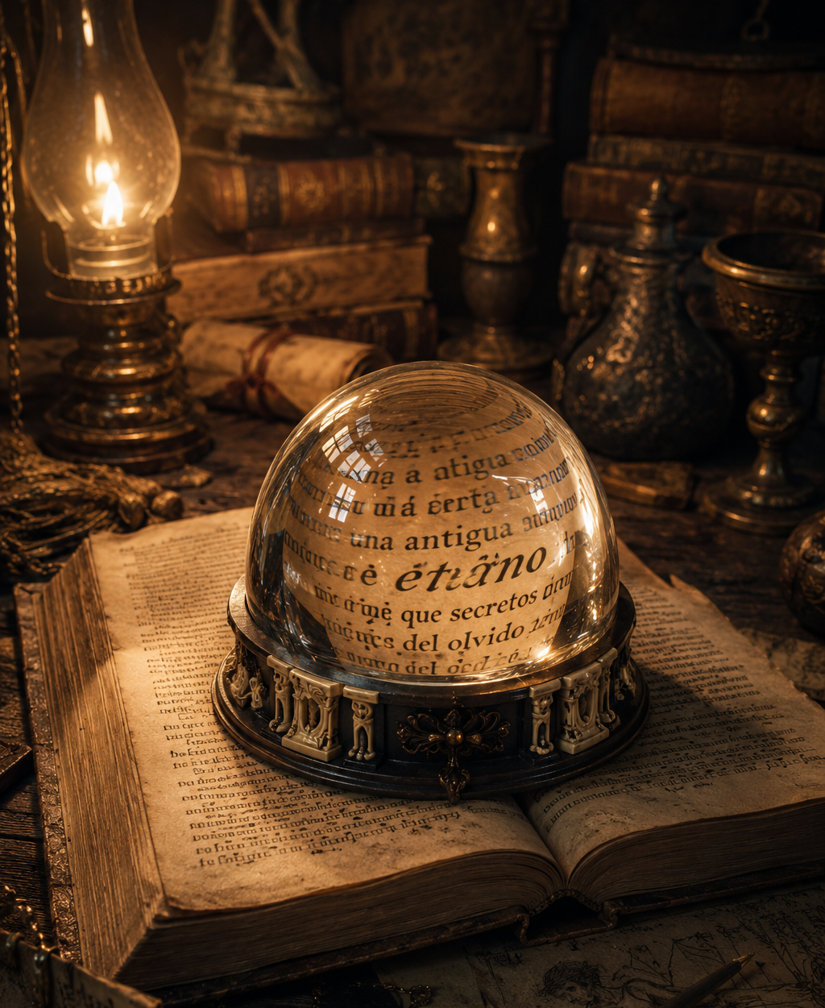
✧ The Crystal Ball ✧

Part 2 – The Purchase
Dahg continued examining the lens for several minutes. He studied it from different angles, inspected the engravings on its base, and carefully ran his fingers over the ebony and ivory.
The piece appeared to be old.
It showed no significant damage, yet the wear visible in certain places revealed that it had passed through many hands over the years. In the deepest recesses of the engravings, traces of dark dust still remained, left there by the slow passage of time.
— Do you know who made it? —Dahg asked.
The woman shook her head.
— No.
— And where does it come from?
— I don’t know that either.
The answer surprised the merchant. The woman seemed to notice.
— I bought it about a year ago at an antiques market in Prosperous City. The seller didn’t know its origin either. According to him, it had belonged to another dealer before he acquired it. And that dealer had obtained it from someone else.
Dahg nodded slowly.
That was not as unusual as it might sound. Many old objects found their way into auction houses after passing through countless owners.
Yet in this case, the situation was particularly striking. An item so unusual would normally be accompanied by stories, documents, or records that allowed at least part of its history to be traced.
This one, however, seemed to have left behind nothing but a chain of nameless owners. As though it had been passed from hand to hand for years. As though no one had kept it long enough to discover where it had come from.
Dahg looked at the lens once more. The longer he studied it, the more convinced he became that he was looking at an exceptional piece. The quality of the materials. The precision of the crystal. The complexity of the engravings. Everything suggested it had been crafted by extraordinary artisans.
And that meant only one thing.
It was worth a great deal of money. Perhaps more than he could afford at that moment. Even so, he decided to try.
— How much are you asking for it?
The woman answered immediately.
— Ten coins.
Her tone was firm and final. As though the decision had been made long before she entered the shop.
Dahg remained silent for several seconds. He had spent his entire life buying and selling things. He understood the rules of a negotiation perfectly well. The seller named a price. The buyer offered another. They argued. They bargained. They searched for common ground. That was how such matters worked. But not this time. The amount was absurdly low. It was nowhere near the true value of the piece.
For a moment, he wondered whether the woman simply did not realize what she was selling.
Yet her manner, her education, and the way she had presented the object ruled out that possibility. She knew exactly what she had. And yet she was willing to sell it for a fraction of its worth.
Dahg asked no further questions. He walked to the room behind the counter. There he unlocked a small iron strongbox. He removed a leather pouch. And returned to the table.
Carefully, he counted out ten coins. One by one.
Then he placed them before the woman. She barely glanced at them. She gathered them up immediately. Put the money away. And rose to her feet.
— It has been a pleasure doing business with you, Master Dahg.
— The pleasure is mine, madam.
The woman inclined her head slightly. Then she turned toward the door. And left.
Dahg watched her through the window as she walked away. He expected to see her stop at one of the market stalls or exchange words with an acquaintance. But she did neither.
She crossed the street at a brisk pace. Then, rounding the corner of the neighboring building, disappeared into the crowd. As though she had been eager to leave. As though the true purpose of her visit had not been to sell the lens.

But to be rid of it.

✦ ✦ ✦

Part 3 – A Closer Examination
As soon as the woman left the shop, Dahg turned his full attention back to the strange reading lens.
He placed it on the counter and began examining it carefully. Now that it belonged to him, he could study every detail at his leisure.
The ebony-and-ivory base was just as impressive as it had been at first sight. Yet upon closer inspection, he discovered small cracks in parts of the wood and signs of wear along the more prominent carvings.
Nothing serious. A little cleaning. Some wax. Perhaps a light polishing.
With a few minor repairs, it would recover much of its former splendor. And then he could sell it for a considerable sum.
Dahg smiled. He had made an excellent purchase. Opportunities like that came along only a handful of times in a lifetime.
At that moment, the bell above the door rang. A customer had entered the shop looking for carpentry tools. Dahg set the lens aside and returned to his duties.
Then more visitors arrived. A farmer interested in a lamp. An elderly woman searching for an iron pot. A traveler hoping to sell a bundle of blankets. And before he realized it, afternoon had given way to night.
By the time he finally closed the shop and extinguished the last candles in the main hall, he was tired.
He slowly climbed the stairs leading to his rooms. He was about to go to bed when he remembered the lens. For some reason, he did not want the day to end without looking at it one more time. He went back for it. And carried it with him to his bedroom.
The room was simple. A bed. A wardrobe. A worktable. Several shelves crowded with books and documents.
Dahg placed the lens upon the table and pulled an oil lamp closer.
Then he picked up his ledger. If the instrument had truly been designed to make reading easier, there could be no better test than a long list of numbers. He carefully rested the flat surface of the crystal upon one of the pages. And looked.
The figures appeared enlarged with astonishing clarity. Every stroke. Every line. Every tiny detail of the handwriting. Everything seemed sharper. Easier to distinguish.
Dahg smiled with satisfaction. The woman had told the truth. It was a magnificent tool.
He slowly moved the lens across different pages of the ledger, reviewing old entries. And then something strange happened.
At first, he thought it was merely a reflection.
A faint mist appeared within the crystal. It was barely visible. A thin, whitish cloud that seemed to drift beneath the surface.
The mist began to spread. Growing denser. More opaque. Until it completely obscured the writing beneath.
The merchant lifted the lens from the book. He held it up to the light. He saw no cracks. No moisture. No defect of any kind. And yet the mist remained.
He turned the object over. Tilted it. Held it closer to the lamp.
Nothing changed.
For a moment, he thought it might be a reflection coming from the window.
He rose from his chair and drew the curtain shut. Then he returned.
The mist was still floating within the crystal. And now it seemed to be moving. Dahg felt a faint chill run through him. He moved the lamp farther away. Then brought it closer again. Once more, he examined the surface. That was when he noticed something that made his heart skip a beat.
Shapes were beginning to emerge within the white clouds. Shadows. Tiny figures that seemed to move slowly. As though he were watching something taking place far away. As though the crystal had become a window.
Unable to understand what he was seeing, Dahg leaned forward. Closer and closer. Until his face was only inches from the sphere.
And at last, he was able to make out a human figure.

A figure that seemed disturbingly familiar.

✦ ✦ ✦

Chapter 3 – Knowledge
Part 1 – The Vision
The crystal no longer showed the pages of the ledger. The numbers and handwritten entries had vanished completely behind the strange white mist that now filled the interior of the sphere.
The mist continued to move slowly. Turning upon itself. Like clouds driven by an invisible wind. And little by little, it began to clear.
First came shadows. Then shapes. And finally, an entire scene. Dahg held his breath.
He was looking at the main street of Drywind. He recognized it immediately. The market road. The fronts of the houses. The stone fountain beside the square. Everything was there. And then he saw himself.
The shock was so great that he jerked back from the table. For several seconds, he remained motionless. Watching. Unable to understand. The man inside the sphere was him. There could be no doubt. The same clothes. The same hat. The same way of walking.
The scene showed him closing the doors of the auction house at the end of the day.
The sun was sinking toward the horizon. The shadows were long. And the light carried that reddish glow that comes in the final moments before evening. Slowly, Dahg leaned closer again. The image was impossible.
Mrs. Alhat appeared in the street as well.
The old woman was waiting atop the driver’s seat of her wagon, drawn by the gray mule she used to transport goods between Drywind and the neighboring villages. Dahg watched as his other self approached. They exchanged a few words. Then he climbed into the wagon, and together they set off down the main road.
The wagon rolled slowly to the end of the avenue. There it stopped beside Omhp’s house.
The old farmer stepped out onto the road. He seemed to be speaking with them. The three remained there for several minutes. Then the wagon moved on.
The image shifted. Now it showed the road leading toward the river. The shadows had grown even longer. The journey appeared to be proceeding normally. Until something strange happened.
A brilliant flash of lightning streaked across the sky.
Even within the sphere, the flash was dazzling. And at that very instant, the mule stopped.
It simply stopped walking. Dahg watched as Mrs. Alhat pulled on the reins. Then climbed down from the wagon. His other self climbed down as well. Both seemed to be trying to persuade the animal to continue.
But the mule remained motionless.
Like a statue. The scene continued for quite some time. At last, he saw himself bid farewell to Mrs. Alhat. Then continue the journey on foot.
The sphere shifted once more. Now it showed Penht’s farm.
The young man emerged from one of the barns. Dahg smiled when he recognized him. He cared for Penht as though he were the son he had never had.
The two spoke for a few moments. Then Penht pointed toward the road. Finally, both climbed into the young man’s wagon and continued toward the river together.
The vision moved forward once again. And the dock appeared. Dahg felt a chill run through him. He knew that place well. It was where he was supposed to board the riverboat in a few days’ time for his journey to Prosperous City. He watched as the wagon drew nearer. Closer and closer. Until the river came into view. And then he saw it.
The riverboat was pulling away from the dock. Its sails unfurled. The current carrying it slowly downstream.
Inside the sphere, Dahg stood motionless, watching the vessel drift away.
Then he seemed to say something to Penht. The two remained there for a few moments. And finally, they turned around. The wagon departed from the dock. The image began to fade. The shapes lost their clarity.
And before long, the white mist once again filled the interior of the crystal. Dahg remained motionless. His gaze fixed upon the sphere.

Trying to understand what he had just witnessed.

✦ ✦ ✦

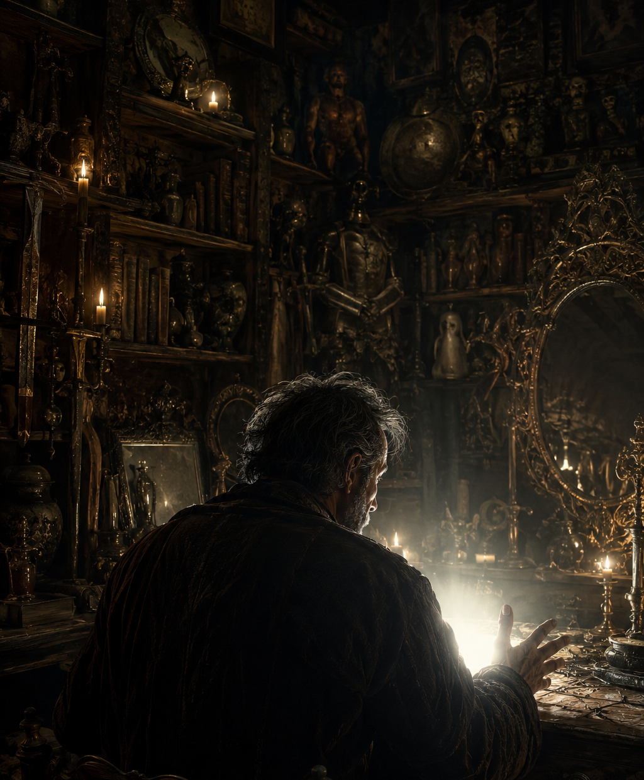
✧ The Vision ✧

Part 2 – The Meaning
For several minutes, Dahg remained seated at the table, unable to take his eyes off the sphere.
The mist had vanished. The crystal was once again perfectly transparent. As though nothing had happened.
As though the strange vision had been nothing more than an illusion brought on by fatigue.
But Dahg knew better.
He had recognized every place. Every person. Every detail. It could not have been a coincidence. And the more he thought about it, the more obvious the answer became.
The sphere was showing him the future.
A chill ran through him. The idea was absurd. Impossible.
And yet it explained perfectly what he had just witnessed.
They were not memories. Nor were they dreams.
They were events that had not yet taken place.
He rose from his chair and began pacing slowly around the room. Trying to put his thoughts in order.
In a few days, he was due to travel to Prosperous City. Everything had already been arranged. He had purchased his passage. He had organized the journey. And the scribe was expecting him to prepare the documents required for the sale of the land he had inherited.
That transaction was one of the most important pieces of his plans.
With that money, he would expand the business. Acquire new merchandise. Seek customers in other places. And make full use of the opportunities offered by his new wagon.
And now the sphere was showing him that he would miss the riverboat.
He stopped beside the window. And looked out into the darkness that blanketed the village streets.
Missing the riverboat would mean losing his passage. But that was the least of it. The real problem would be the delay. Perhaps the scribe would not be able to see him again for weeks. Perhaps the sale would be postponed for months. Maybe even until the following year.
The thought filled him with unease.
He was no longer a young man. He had spent decades building that business. Decades saving coin after coin. And although he rarely admitted it aloud, he was beginning to feel the weight of the years. He did not want to keep waiting. He did not want to postpone, once again, the changes he had planned for so long.
He needed things to move forward. He needed the future to begin at last.
He looked at the sphere again.
And then something changed in the way he saw it.
The worry gradually faded. Replaced by something entirely different.
An advantage.
Because the vision showed something that had not yet happened. And that meant he could still act.
He immediately understood the true value of the information.
The sphere had not shown him an unavoidable misfortune.
It had shown him a problem before it occurred.
A warning. An opportunity.
A chance to correct his mistakes before making them.
A slow smile spread across his face. Now he knew the cause of the delay. The conversation with Omhp. The trouble with Mrs. Alhat’s mule. The setbacks along the road. It was all there.
And it could all be avoided.

He stepped closer to the table.
Rested a hand upon the crystal. And felt at peace.
— I am not going to miss that riverboat —he murmured.
Then he looked at the sphere once more.
Motionless. Silent. Harmless.

And he thought that perhaps
he had just made the best purchase of his entire life.

✦ ✦ ✦

Part 3 – The Plan
The answer was obvious.
He did not need to change anything major. He only needed to avoid the delays. Nothing more.
He sat down beside the table once again and went over the vision in his mind. The conversation with Omhp. Mrs. Alhat’s wagon. The mule stopping beside the road. Each delay had added a few minutes to the journey. Minutes that had ultimately cost him the riverboat.
But now he knew the problem. And knowing the problem was the first step toward solving it.
Mrs. Alhat often offered him a ride to the dock whenever their journeys happened to coincide. She was a good neighbor and was always willing to help.
However, her old mule could be unpredictable. Sometimes it stopped for no apparent reason, refused to cross a bridge, or simply would not continue along certain roads.
Dahg should have taken that into account from the beginning.
But it was not too late to correct it. He would speak with her the following day. He would thank her for the offer. And explain that he preferred to make the journey on foot. After all, the distance was not that great. He could easily walk it.
And if he avoided wasting time along the way, he would reach the dock with plenty of time to spare.
Nor would he stop to speak with Omhp. The old farmer was a kind man, but he enjoyed long conversations. This time, Dahg would have to apologize and continue walking. It was that simple.
The more he thought about it, the more certain he became that it would work. The vision had shown him exactly where the problem lay. And he had just found the solution.
A feeling of relief began to replace the worry he had felt moments before.
After all, it was not a matter of life and death. The village was not burning down.
It was only a matter of arriving at a boat on time.
Nothing more. And now that he knew the obstacles, he had no reason to fail.
Finally, he extinguished the lamp. Lay down. And slept better than he would have imagined.
Over the following days, he barely thought about the sphere.
He carried out his usual duties. Served customers. Organized merchandise. Prepared documents. And arranged everything necessary for the journey.
Just as he had decided, he spoke with Mrs. Alhat and politely declined her help. The old woman seemed surprised, but did not insist. The preparations continued. And the days passed. Until finally, the appointed date arrived.
The afternoon of the journey passed with apparent normality. Dahg checked his documents one final time. Made sure he had the necessary money with him. And ensured that nothing remained unfinished in the shop.
Only then, when he was about to leave, did he feel a small uneasiness return.
It was not fear. Nor was it doubt. Only an uncomfortable sensation he could not explain.
He remained still for a few moments beside the door. Remembering the vision. Remembering the riverboat disappearing down the river. Remembering the strange mist that had filled the crystal.
None of that mattered anymore.

He had anticipated the delays.
He had taken precautions.
He had corrected the problem.

I will arrive on time, he told himself.

Outside, the sun was beginning to sink toward the horizon.
Some dark clouds were slowly gathering in the distance.
He took his hat.
Opened the door.
Closed it behind him.

And began walking toward the dock.

✦ ✦ ✦

Act II - Intervention
“Not always shall there be
a perfect solution.

At times, the true challenge is
to possess the wisdom to choose the best
among those that may be.”

—Fabhrius

Chapter 1 – Omhp
Part 1 – Dahg Begins the Journey
Day: Friday. Time: 7 p.m. Dahg left the auction house and began walking toward the river dock. He carried with him a small bag containing documents, a few coins, and everything he needed for the journey.
It was an important day.
In Prosperous City, a scribe was waiting for him to prepare the documents for the sale of some land he had inherited many years before. That transaction represented an exceptional opportunity to expand his business and set in motion the plans he had been preparing for so long.
He locked the shop door. Out of habit, he checked that the shutters were securely fastened. Then he began to walk.
The sun was slowly descending over the rooftops of Drywind. The long shadows of the houses stretched across the main road while a gentle breeze stirred the branches of the trees.
Far away, over the plains, a few gray clouds were beginning to gather along the horizon. Nothing unusual. Probably one of those passing storms that often appeared at the end of summer.
Dahg continued at a steady pace. He knew the road perfectly well. He had traveled that path dozens of times over the years. And he intended not to repeat the mistakes he had seen in the sphere. He would not travel with Mrs. Alhat. He would not waste time waiting for a stubborn mule. And he would not stop to speak with anyone.
That was the difference. That was the advantage the vision had given him. He smiled to himself. Everything was under control. He had left with time to spare.

And as he left the last houses of the village behind, he was certain that nothing could prevent him from reaching the dock on time.

✦ ✦ ✦

Part 2 – The Encounter with Omhp
He had not walked very far when he reached the end of the main road. There, beside a small wooden fence, stood Omhp’s property.
The old farmer was working near the roadside. When he saw Dahg, he raised a hand in greeting. Then he stopped what he was doing and began walking toward him.
Dahg felt an uncomfortable sense of familiarity. He had seen this before. The sphere had shown it to him clearly. Right there, in that exact place. With Omhp.
For a moment, he was tempted to keep walking without stopping. But he dismissed the idea immediately. Omp was a good neighbor. And besides, he seemed troubled. So Dahg stepped closer and waited.
— Good afternoon, Dahg.
— Good afternoon, Omhp.
The farmer rested both hands on the fence and sighed.
— I was wondering if you could give me your opinion about a problem I’ve been having.
Dahg listened carefully.
Omp explained that over the past few weeks he had discovered numerous tunnels throughout several of his fields. At first, he believed they were caused by a few moles, but the situation appeared to be getting worse. Now he had also found marmot burrows. The animals were damaging the roots of some crops and were beginning to pose a threat to the harvest.
— I remember you had something similar happen last year, —Omhp said—. I thought perhaps you might know what to do.
Dahg nodded slowly. It was true. He had faced similar problems on some land near the river and had managed to solve them after several weeks of work. He understood the farmer’s concern perfectly. And he also understood that the conversation could easily continue much longer than was convenient.
He glanced briefly toward the road. Then looked back at Omhp.
— I would like to help you right now, —he replied—, but I need to reach the dock before nine. The riverboat to Prosperous City leaves tonight, and I cannot afford to miss it.
The farmer looked disappointed. Only slightly.
— I understand.
— I’ll come back tomorrow afternoon, and we can look at the problem together. We’ll inspect the fields and find a solution.
Omp’s expression softened.
— I would appreciate that.
— Don’t worry. We’ll solve it.
The two men exchanged a few final words. Then they shook hands. And finally, Dahg continued on his way.
As he walked away, he felt a growing sense of satisfaction. The conversation had been brief. Much shorter than the one he had witnessed inside the sphere. He had avoided the delay. He had followed his plan. And at the same time, he had not failed to help a neighbor who needed his advice.
He smiled to himself.
Things were working exactly as he had predicted.

Now he only had to keep walking.

✦ ✦ ✦

Part 3 – Omhp Leaves with His Wagon
Omp remained beside the fence, watching as Dahg walked away along the road.
The merchant was moving at a steady pace. Without stopping. Without looking back. After a few minutes, his figure became a small dark silhouette against the plains. And finally disappeared beyond a gentle rise in the land.
The old farmer returned to his work.
He tried to focus on his tasks. But the marmots continued to occupy his thoughts. The situation was beginning to worry him more than he was willing to admit. If he did not act soon, the harvest could be seriously affected.
He remained there for several minutes, thinking. Then he remembered something. Cumhp. His neighbor to the south.
The previous year, he had faced similar problems in several of his fields. Perhaps he had already found a solution. And if anyone could offer him good advice, it was probably him.
Omp looked toward the road.

Cumhp’s farm was not very far away. He could go. Speak with him. And return before night had fully fallen.
The decision seemed reasonable. So he headed toward the stable. And shortly afterward, he rode out driving his old wagon.
The horse moved along the path with a nervous step.
More restless than usual. It flicked its ears. Shook its head. And struck the ground impatiently with its hooves.
— What is wrong with you today? —the farmer murmured—.
Omp then looked up at the sky.
The clouds continued gathering over the plains. The storm that had once seemed distant was beginning to take shape. A massive dark cloud was slowly advancing from the west.
Perhaps the horse was reacting to that.
Probably nothing to worry about. He gently pulled on the reins and continued forward.
It was not long before he spotted Dahg walking along the main road.
The merchant was already near the bend that led toward the mills. The distance between them slowly grew smaller.

Omp smiled.
He thought he could give him a ride to the dock. Cumhp’s farm was practically in the same direction.
And this way Dahg would still reach his riverboat even earlier.

It seemed like a good idea.

✦ ✦ ✦

Part 4 – The Sound of Thunder
Omp gently pulled on the reins. The horse began to trot. The distance separating them from Dahg was now very small. Only a few yards.
The merchant was walking calmly along the edge of the road. Omp opened his mouth to call out to him. And then it happened.
A bolt of lightning tore across the sky.
It was not the distant flash of a faraway storm. It was a blinding discharge. Brutal. Instantaneous. The lightning struck a tree standing very close to the road. The explosion shook the air. The thunder erupted with such sudden violence that it seemed to tear the sky apart above them.
The horse reared up. It let out a terrified whinny. And bolted forward.
Omp pulled on the reins with all his strength. Too late. The animal no longer obeyed. It had panicked. The wagon lunged forward, bouncing violently along the road.
— No!
Omp’s cry was lost beneath the thunder.
Dahg turned just in time to see the horse charging toward him.
There was no time to move aside. No time to run. No time for anything.
The impact was brutal.
The horse struck him directly.
Dahg was thrown off the road. He rolled across the ground among stones and weeds. A sharp pain shot through his leg.
The wagon passed beside him like a mass of wood and iron gone out of control.
Omp remained gripping the reins, desperately trying to regain control.
The horse kept accelerating.
Faster and faster.
Farther and farther away.

Dragging the runaway wagon toward the village.

✦ ✦ ✦

Part 5 – Fire
Dahg remained lying beside the road.
He was dazed. He tried to stand, but a sharp pain shot through his knee and he collapsed back onto the ground.
A moment later, he heard the impact. A dry sound. Violent. The sound of something heavy striking with tremendous force. Of wood breaking apart.
Then came the screams. Distant voices. Confused. Alarmed.
He lifted his head, trying to understand what had happened. For the first few seconds, everything seemed normal.
But then the smoke appeared. A dark column began slowly rising into the sky. It seemed to be coming from the warehouse beside the main road.
Then he saw the flames. An orange glow flickering behind the rooftops. The building appeared to be burning.
The fire quickly became impossible to ignore.
It was growing.

Shortly afterward, there was an explosion.
The blast echoed through the air.
He felt the impact in his chest.
And as the smoke darkened the evening sky,
Dahg remained on the ground beside the road,
motionless and helpless.

Watching in horror from a distance as Drywind began to burn.

✦ ✦ ✦

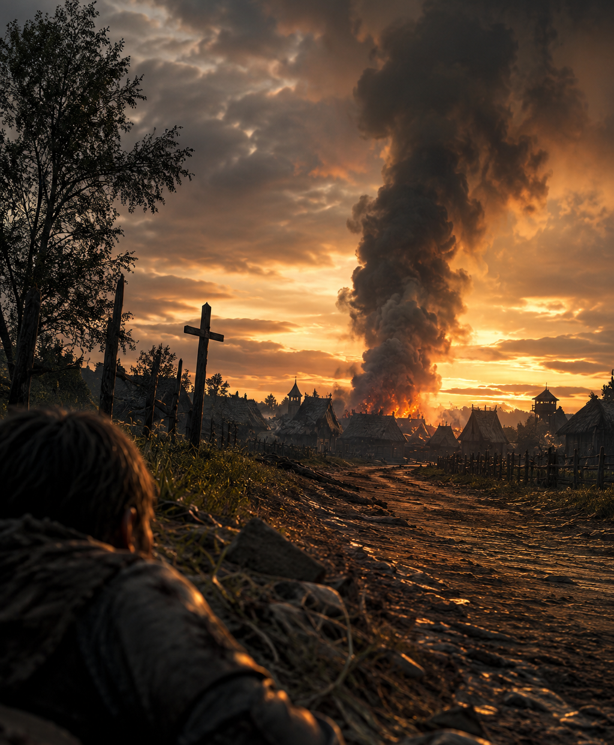
✧ Fire ✧

Chapter 2 – Alhat
Part 1 – Dahg Leaves Home
Day: Friday. Time: 7 p.m. Inside the shop, Dahg was making his final preparations before leaving. At nine o’clock that evening, he was due to board the boat that would carry him to the city.
Shortly before seven, he locked the doors of the auction house and set off on foot toward the river dock.
He carried with him the documents for his meeting with the scribe in Prosperous City, as well as the hope that this journey would mark the beginning of a better future for his business.
He walked with a steady stride. The evening air was pleasant. A gentle breeze drifted through the streets of Drywind as the warmth of the day slowly faded away.
Out across the plains, dark clouds were gathering on the horizon.
The shops along the market road were beginning to close their doors. And the streets were slowly emptying.
As he reached the edge of the village, Dahg spotted Omhp working beside the fence surrounding his property.
The old farmer raised a hand in greeting. Then stepped over to the roadside.
For a few minutes, they spoke about several problems that had been affecting his crops.
Omhp had hoped for some advice. But Dahg was in a hurry.
He explained that he had to board the boat that very night and promised to return the following day to help him.
The two men parted on friendly terms.

And Dahg continued on his way.

✦ ✦ ✦

Part 2 – Bound for the Warehouse
Not far from there, at the southern edge of Drywind, Mrs. Alhat was finishing her daily chores.
The elderly woman moved slowly through the pens, making sure all the animals were secure before nightfall.
The clouds were gathering more quickly now. A storm seemed to be forming over the plains. And although it had not yet begun to rain, the air carried that familiar scent that foretold a change in the weather.
Mrs. Alhat watched the sky for a moment. Then returned to her work. She had lived alone for many years. Her small farm covered only a few acres, but it was enough to provide a simple and peaceful life.
She kept half a dozen goats. A few pigs. A flock of sheep. Several chickens. And an old gray mule that had been at her side for so long that she thought of it more as a friend than a beast of burden.
And although the work was never truly finished, she rarely complained. She was a patient woman. Practical. Accustomed to solving problems through hard work and perseverance.
Once she had finished checking the pens, she made sure the animals had enough water to last through the night.
Only then did she remember the order waiting for her at the village warehouse. She had purchased several sacks of grain. Oil. A few tools. And other supplies she would need in the weeks ahead.
She glanced up at the sky once more. There was still time. If she hurried, she could collect everything before the storm arrived.
She readied the wagon. Hitched the mule. And soon afterward left the farm.
Her old companion moved along at its usual unhurried pace while the wagon wheels creaked softly on the road. Mrs. Alhat smiled. According to the original plan, she would have been taking Dahg to the river dock that evening. But the merchant had decided to walk instead.
Which meant she now had some free time.

And she had decided to use it to collect the supplies she needed.
No hurry. No worries.

✦ ✦ ✦

Part 3 – The Thunderclap
Mrs. Alhat arrived at the warehouse shortly afterward.
The building stood beside the main road, near the northern entrance to Drywind. It was one of the largest structures in the village.
A massive wooden building erected many years before, resembling an enormous barn. The ground floor served as a storage depot for merchandise. The upper level was used to store surplus grain, tools, and materials that were not needed on a regular basis. A wide porch stretched across the entire front of the building. Beneath its roof were piled sacks, barrels, crates, and every sort of goods awaiting collection or distribution.
At that hour, there was still plenty of activity. Several farmers were finishing their purchases. A pair of teamsters stood near the entrance arguing over prices. Two laborers were unloading cargo from a river barge that had arrived that very morning. And Xenhk, the warehouse owner, was personally attending to the last customers of the day. It seemed as though all the daily life of Drywind had gathered there.
Mrs. Alhat brought her wagon to a stop in front of the porch.
Her order was already waiting. Everything had been stacked against the front wall of the building.
Very close to a long row of enormous clay jars filled with oil.
There were dozens of them. Large containers sealed with wax and treated cloth. Some stood nearly as tall as a person. Others had been stacked atop one another, forming veritable walls of pottery. Oil was one of the most valuable commodities Xenhk stored. And that week he had received an especially large shipment.
Mrs. Alhat exchanged a few words with the merchant. They spoke of the weather. Of the harvest. And of the storm that seemed to be rolling in across the plains. Then she began slowly loading the sacks into her wagon.
The old mule waited patiently. Motionless. With the calm of one that had performed the same routine hundreds of times before.
Several minutes passed. The wagon was nearly loaded. Mrs. Alhat was lifting one of the last sacks when it happened.
A blinding flash tore across the sky.
So bright that, for an instant, it seemed to turn evening into broad daylight. Lightning struck somewhere in the nearby fields. The bolt hit the earth with terrifying force. And at that very moment came the thunder. A crash so violent it seemed to split the world in two.

Mrs. Alhat involuntarily dropped the sack she was carrying.
The mule leapt sideways.
The old woman needed a moment to recover. Then she burst out laughing.
— Did that frighten you? —she asked—, stroking the animal’s neck.
The mule snorted. And that only made her laugh harder. It was a brief moment. A small pause in an otherwise ordinary evening.
Until something appeared around the bend in the road.
A wagon.

It was moving at an impossible speed.
Out of control.

✦ ✦ ✦

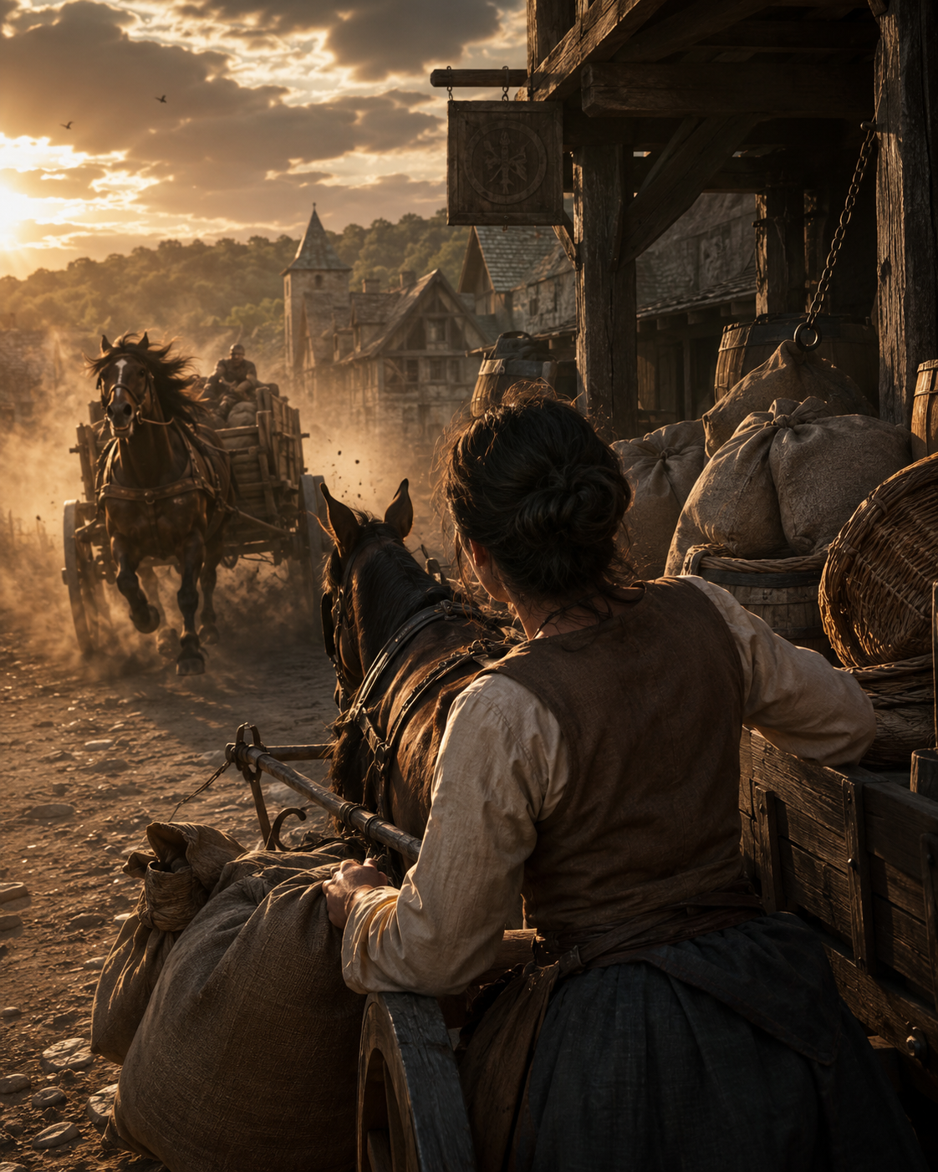
✧ A Wagon Out of Control ✧

Part 4 – A Wagon Out of Control
Mrs. Alhat had no time to react.
The wagon burst around the bend like a projectile.
And came hurtling straight toward her.
It slammed into Mrs. Alhat’s wagon with a deafening crash. And together, the two wagons smashed through the front wall of the warehouse. They burst into the building like a battering ram.
Plowing through the oil jars stacked along the front of the structure.
One of the oil lamps hanging from the ceiling was torn loose by the impact.
Its flame touched the spilled oil.
And the fire began.
Within seconds, the entire building was ablaze.
The heat became unbearable. Old Omhp and Mrs. Alhat were trapped inside a prison of burning wood.
The intense heat reached the oil jars that had remained intact and triggered an explosion.
The fire doubled in size in a matter of seconds.
And then the neighboring buildings began to burn.

Not far away,
beside the bend in the road leading to the dock,
Dahg was trying to understand what was happening.
Watching the scene in horror from the ground.

✦ ✦ ✦

Chapter 3 – Penht
Part 1 – Dahg Leaves His House
Day: Friday. Time: 7 p.m. Shortly after seven in the evening, Dahg locked the door of the auction house and began walking toward the river dock.
He needed to arrive before nine in order to board the riverboat that would take him to Prosperous City.
As he passed by Omhp’s property, he stopped for a few minutes to greet his friend. They spoke briefly. Then Dahg continued walking.
He had left with enough time and with the firm intention of not missing the boat.
The clouds were beginning to cover the sky when he reached the bend in the road.
A powerful thunderclap echoed across the plains.
The sound was so sudden that Dahg instinctively turned toward the open fields.
And at that very moment, a runaway wagon appeared behind him.
He had no time to move aside.
The impact threw him off the road. He fell violently to the ground.
The wagon continued forward without stopping. A few seconds later, it disappeared around the bend.
A loud crash was heard. The wagon had struck something.
Shortly afterward, a column of smoke began rising above the rooftops of Drywind.
Dahg tried to stand. A sharp pain in his knee prevented him.
From the ground, he watched as the smoke grew larger.

Then the first flames appeared.

✦ ✦ ✦

Part 2 – A Column of Smoke
Not far from there, beside the riverbank, the same thunder also caught Penht’s attention.
Penht was a young farmer in his early thirties. He had been born in Drywind and had spent his entire life there. Hardworking, responsible, and always willing to help others, he was the kind of person who seemed to get along with everyone.
Many of the villagers appreciated him. And Dahg appreciated him more than anyone. Over the years, he had come to think of him almost as a son.
That afternoon, Penht was finishing his work on the farm. The sound of thunder made him look up at the sky. A storm seemed to be forming over the region. The dark clouds continued gathering slowly and were moving in from the plains.
Penht grew corn and raised a small group of horses. He thought it would be wise to bring the animals indoors before the rain began. He walked to the stable and started settling them inside.
He was closing one of the doors when something caught his attention.

In the distance, above the trees,
a column of smoke was rising along the horizon.
It seemed to be coming directly from the village.
What could have happened?
Then he heard an explosion.
And a moment later, he saw the flames in the distance.

A fire in the village.

✦ ✦ ✦

Part 3 – Help
Penht did not waste any time. He left the stable, mounted one of his horses, and rode toward the village at a gallop.
The column of smoke grew larger with every passing minute. And the closer he came, the more obvious the scale of the fire became.
A few minutes later, he reached the first houses of Drywind.
The air smelled of smoke. Small ashes drifted through the wind. The villagers were running from one place to another, carrying buckets of water, tools, and anything that might help fight the flames.
Penht continued along the main road.
Several houses were already burning. Others were being evacuated as a precaution. The inhabitants were trying to save furniture, tools, animals, and supplies before the fire reached their homes.
The fire appeared to have started near the warehouse. From there, it had spread to the nearest buildings. The flames rose above the rooftops, and a thick cloud of smoke covered much of the center of the village.
Penht tried to get closer. But the heat was too intense. And the smoke too thick. He understood that reaching the warehouse was impossible. He stopped for a moment to assess the situation.
The villagers working near the fire seemed to be focusing their efforts on preventing the flames from reaching new buildings. It made sense.
The warehouse and the closest houses appeared to be lost. The priority now was to stop the fire from spreading any further.

He dismounted. Tied his horse to a fence. And went to join the others.

✦ ✦ ✦

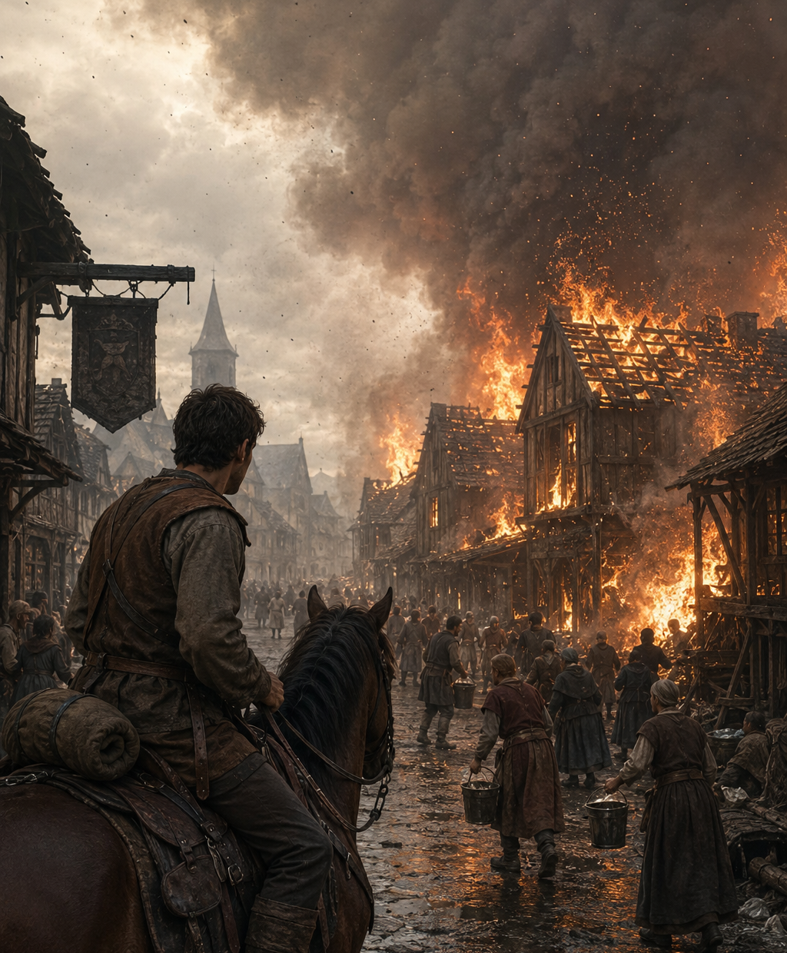
✧ The fire ✧

Part 4 – A Heroic Act
He wanted to help. But he understood that it was impossible to save everything. He had to choose where to act.
Then he heard the sound of horses. They were coming from a stable across the street.
He looked in that direction. The fire had reached one of the outer walls and was beginning to spread across the roof. It was not completely engulfed in flames yet. But there was not much time left. If there were animals inside, they would soon be trapped.
Penht ran across the street.
He pushed open the door.
A wave of hot smoke rushed outside.
He covered his mouth and nose with the sleeve of his shirt and entered.
The interior was filled with smoke. Visibility was poor.
The flames were advancing along one of the walls and beginning to spread through the roof beams.
The horses were at the far end. Terrified. Kicking against the doors of their stalls with their hooves. Trying to escape.
Penht moved toward them.
He freed the first one. The animal bolted toward the exit.
Then he released the second.
The smoke was growing thicker. Breathing was becoming difficult. His eyes burned.
He began to feel dizzy and disoriented.
He continued toward the last stall.
He managed to open the latch. The horse surged forward and ran toward the door.
Penht turned to follow it.
Then he heard a crack.
One of the main beams had given way.
He looked up.
And barely had time to understand what was happening.

Before part of the roof collapsed onto him.

✦ ✦ ✦

Act III - Optimization
“Sometimes,
what appears to be a problem
is actually
the solution to another problem
we have not yet seen.”

— Fabhrius

Chapter 1 – The Hidden Truth
Part 1 – Some Time Later
Three weeks had passed since the day of the fire. The village was slowly returning to its usual rhythm as reconstruction work began on the damaged buildings.
Dahg was still walking with some difficulty because of a knee injury that was finally beginning to heal.
Much harder to overcome was the absence of his friends. And especially that of Penht.
The sale of the land had been put on hold. He would resume the arrangements, perhaps, the following spring.
For now, he needed time and peace of mind.
That morning, he felt more energetic. He decided to put the shop in order. Move some furniture. Clean. Give the displayed items a better appearance.

He spent several hours reorganizing merchandise and removing the accumulated dust, until his attention fell upon the crystal ball.
It remained exactly where he had left it that night. He had not touched it since then. He thought that perhaps he could resume the restoration work he had planned to carry out before putting it up for sale.
He picked it up. He examined it carefully.
Turned it from side to side. It was still an extraordinary object.
Beautiful. Intriguing. And deeply unsettling.
What he had seen that night still had no explanation.
Had it truly shown the future?
Or had everything been nothing more than a strange illusion created by his own imagination?
And yet, he had missed the riverboat. He had encountered Omhp. And the lightning had struck exactly as he had seen.
Coincidences?
Perhaps.

And if the crystal ball showed the future…
Why was it silent now?
Dahg carefully placed it back on the table and stepped away.
The mystery grew in his mind. He remained there, watching it. Thinking. Trying to understand.
And then it happened again.
A thin thread of white smoke appeared inside the crystal.
It slowly spread. Swirled around itself. And eventually filled the entire sphere, turning it completely opaque.
Dahg felt a chill run through him.
The sight sent a cold shiver down his spine.
Now it no longer seemed like a creation of his imagination.
And he was not sure he wanted to see what it would show him this time.

But he could not look away.

✦ ✦ ✦

Part 2 – A New Vision
The image became clearer.
Dahg was moving slowly along the road toward the old bridge. He recognized the place immediately. It was the route leading to Leavebehind, a small village in the western valley that he often visited for business.
In the distance, the silhouette of the bridge appeared.
And on it, a wagon.
Dahg felt an immediate sense of unease. No one had used that bridge for years. The wooden planks were rotten, and several of the beams had already given way. The villagers preferred to travel several additional miles rather than risk crossing it. As he approached, he realized the situation was even worse than it had seemed.
One of the wagon wheels had broken through the wooden decking and become trapped between the beams.
The horse had already been unhitched. Its owner stood beside the road, watching helplessly.
They spoke for a few moments. After that, they tied a thick rope between the two wagons. Dahg moved forward slowly. The rope tightened. The trapped wagon did not move. He tried again. The rope became rigid as an iron bar. And suddenly, the wheel came free.
The wagon lurched violently forward. One of the main beams snapped, the entire bridge tilted several inches. And the two wagons were left stranded across the structure.
Dahg tried to make his horse move backward. Too late. The bridge continued collapsing under the weight. The planks broke one after another. He understood that he could no longer save either wagon.
He ran toward the horse and released the harness.
The animal backed away in terror onto solid ground. The two men hurried away. A moment later, the bridge collapsed.
The two wagons vanished beneath a cloud of dust and splintered wood.

Twenty meters below, the Verdastro River swallowed them whole.

✦ ✦ ✦

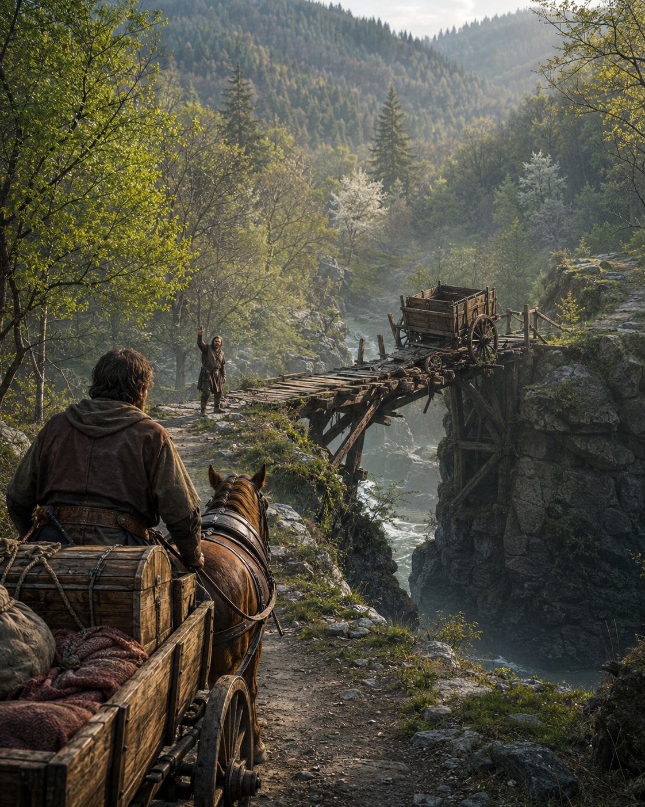
✧ The wagon and the bridge ✧

Part 3 – What Now?
The vision vanished as suddenly as it had appeared. The white smoke disappeared from inside the sphere. And the crystal became nothing more than a simple reading lens once again.
Dahg remained motionless. He could not take his eyes away from it.
He had just seen himself lose the wagon.
His wagon. The very one he had worked for years to obtain. The one into which he had invested all his savings. Without it, he would not be able to transport goods. He would not be able to expand his business. He would not be able to recover from the losses he had suffered after the fire. That wagon was not a luxury. It was his future.
He slowly rose from the chair. And began walking around the room. This was serious. A warning.
He stepped away from the table and continued working in the shop for the rest of the day. He tried to focus on his customers. He organized merchandise. He tried to think about anything else.
But the image of the bridge kept returning again and again. The trapped wagon. The creaking planks. The bridge slowly collapsing. His own wagon disappearing into the river.
That night he went to bed earlier than usual. And he slept poorly. He dreamed of roads that divided into different paths. Of impossible choices.
He woke suddenly before dawn. The room was dark.
He had already made his decision. He had to get rid of that thing. He did not want to see another vision. He did not want to wonder again what he should change. He did not want to continue living at the mercy of futures that did not yet exist.
He dressed. Went downstairs to the shop. And even before opening the doors, he placed the crystal sphere in the display window.
He was no longer trying to make a large profit. Not even to earn anything from it. It was enough if he could recover the money he had paid for it.
He wanted it gone.

As soon as possible.

✦ ✦ ✦

Part 4 – The Sale
That morning he opened the shop with the first rays of sunlight.
He was still removing the covers that protected the display window when he heard the door open.
A man had just entered. He wore high-quality traveling clothes and carried a leather portfolio under one arm. His appearance was distinguished. He did not look like a nobleman, but rather like an educated man. Someone accustomed to working with documents and books.
He glanced around the shop and almost immediately stopped in front of the crystal sphere.
— May I see it? —he asked—.
Dahg nodded. The visitor picked up the object carefully. He examined the ivory carvings. Held the crystal up to the light. Checked the condition of the base. Then he smiled with clear satisfaction. He seemed to know this kind of instrument perfectly.
He explained that he was a scribe. He came from Fogliempilate, a city far to the south, in the region of Mezzapianta. He was traveling on business. That very afternoon he would continue on to Pomagrande, following the river trade route.
For several minutes they spoke about maps, ancient documents, merchant routes, and methods of copying manuscripts.
He was a cultured man. Well-mannered. And extraordinarily pleasant. Dahg enjoyed the conversation.
And yet, something troubled him.
Only a few hours had passed since he had decided to get rid of the sphere. And now, standing before him, was exactly the kind of buyer he needed. A man with money. With enough knowledge to appreciate the object. With a genuine reason to use it. And, on top of that, a traveler who would be leaving the region that very day.
He was, in every possible sense, the perfect customer. It had to be a coincidence. There was no doubt about that. But it was a strangely convenient coincidence.
Finally, the man placed the sphere back on the counter.
— What is your price? —he asked—.
Only then did Dahg hesitate. His gaze fell upon the crystal. He remembered the white smoke. The images. The fire. The bridge. The feeling of witnessing something no human being should ever know. Should he sell it?
That question had no simple answer. He did not know what the sphere truly was. He did not know how it worked. He was not even certain that it was dangerous.
After all, the sphere had not caused the fire. Nor had it brought down the bridge. It had only shown something. Information. Nothing more.
And information was neither good nor bad by itself.
Everything depended on what each person chose to do with it. Perhaps, in the right hands, the object could be useful. Perhaps even beneficial.
Dahg placed both hands on the counter. He looked at the scribe. And answered:

— How much do you believe it is worth?

✦ ✦ ✦

Part 5 – An Imperfect Future
In the days that followed, routine once again surrounded the auction house with its continuous, predictable, and comforting rhythm.
Life slowly returned to its usual appearance. Weeks turned into months. Autumn came and went. Then winter arrived. And almost without realizing it, Dahg welcomed the arrival of spring.
During the winter, he had met the owner of the auction house in Aguasfrías, a village located two days’ journey to the west.
After several conversations, they had agreed to form a business partnership.
Each year, they would exchange the merchandise they were unable to sell in their respective villages, offering those products to new buyers.
The idea seemed promising. And Dahg needed new opportunities.
It seemed like the right time of year to travel to Aguasfrías and exchange goods with his new partner. So one morning, he loaded his wagon with several carefully selected pieces, packed some food for the journey, and left Drywind before dawn.
The weather was pleasant. There were no clouds in the sky. And for several hours he traveled peacefully along the western roads.
As he approached the mountainous region, the forest began to surround the path. The trees cast a pleasant shade over the road. The journey was turning out better than expected.
And shortly before midday, he reached the old bridge.
Then he stopped.
There was a wagon on the bridge.
Dahg felt a chill run through him. He recognized the scene immediately. He had seen it before. Inside a crystal sphere.
He remained motionless, watching. One of the wheels had broken through the wooden decking. The wagon was trapped. From the other side, an unknown man appeared and hurried toward him.
The horse had already been released. But the wagon remained on the bridge. Exactly as it had appeared in the vision.

The man reached him. His expression showed concern.
— Please! Help me! The wheel is trapped between the planks. If I cannot get it out, I will lose it.

Dahg did not answer.
He looked at the bridge.
Then he looked at the stranger’s wagon.
And finally, he turned his eyes toward his own.
The new wagon.
The wagon he had worked for years to obtain.

The stranger spoke again. This time with greater urgency.
— Will you help me?

Dahg remained still.
He looked at the man.
He looked at the trapped wagon.

And then he looked back at his own.

✦ ✦ ✦

End of the Tale
✦
Omniscientis

From the Infinite Library
Catalogued Volumes
◆ The Key
◆ The Crystal Ball
Records Awaiting Cataloguing
◇ The Lamp
◇ The Seed

